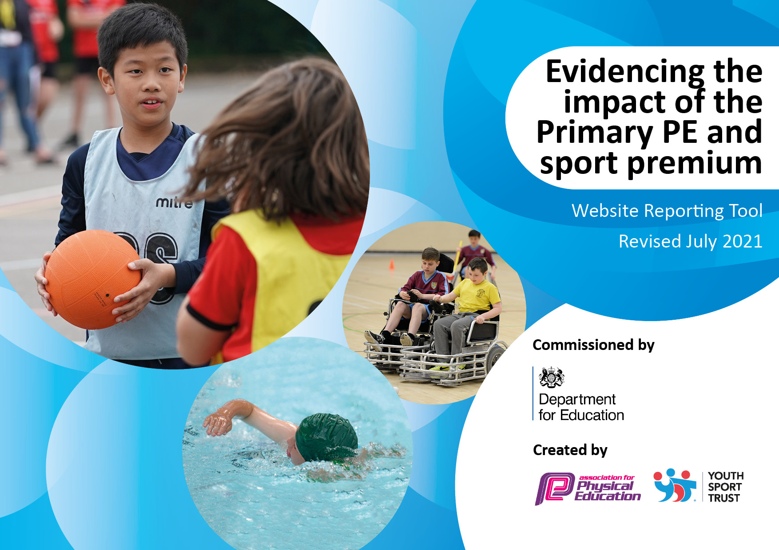
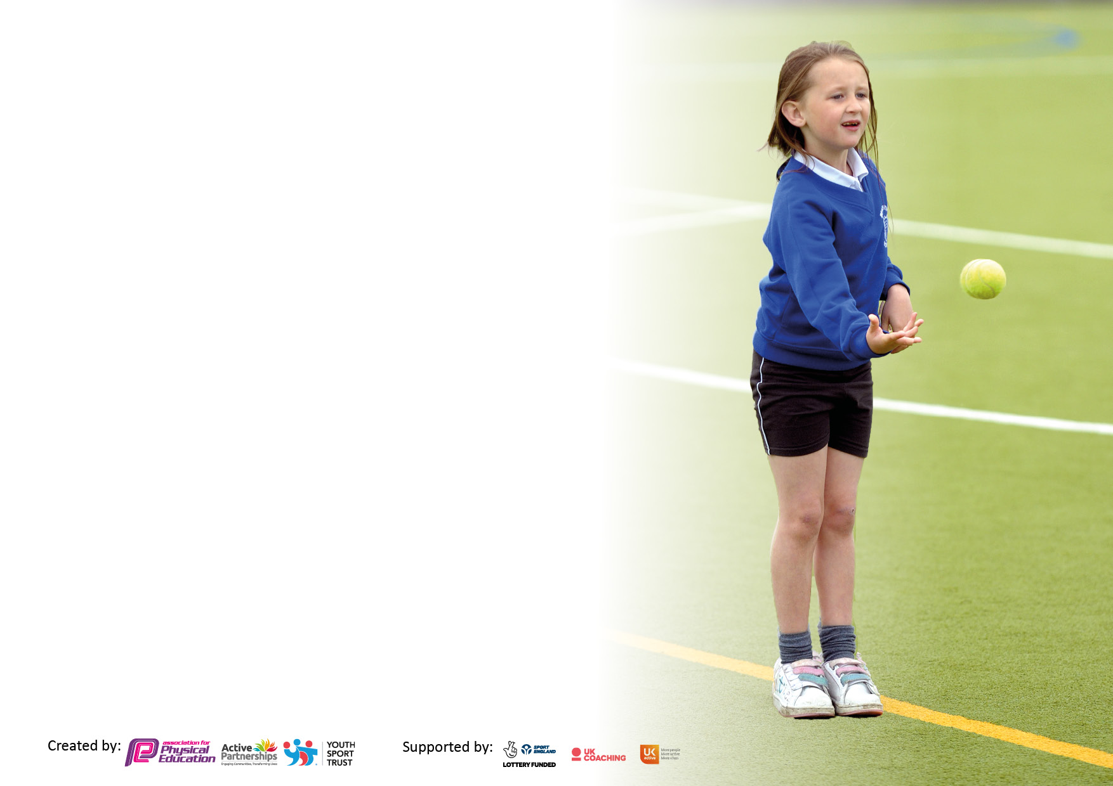

It is important that your grant is used effectively and based on school need. The Education Inspection Framework makes clear there will be a focus on ‘whether leaders and those responsible for governors all understand their respective roles and perform these in a way that enhances the effectiveness of the school’.

Under the Quality of Education Ofsted inspectors consider:
Intent - Curriculum design, coverage and appropriateness
Implementation - Curriculum delivery, Teaching (pedagogy) and Assessment
Impact - Attainment and progress

To assist schools with common transferable language this template has been developed to utilise the same three headings which should make your plans easily transferable between working documents.

Schools must use the funding to make additional and sustainable improvements to the quality of Physical Education, School Sport and Physical Activity (PESSPA) they offer. This means that you should use the Primary PE and sport premium to:

- Develop or add to the PESSPA activities that your school already offer
- Build capacity and capability within the school to ensure that improvements made now will benefit pupils joining the school in future years
- The Primary PE and sport premium should not be used to fund capital spend projects; the school’s budget should fund these.

Pleasevisitgov.ukfortherevisedDfEguidanceincludingthe5keyindicatorsacrosswhichschoolsshoulddemonstrate animprovement.Thisdocumentwillhelpyoutoreviewyourprovisionandtoreportyourspend.DfEencouragesschools to use this template as an effective way of meeting the reporting requirements of the Primary PE and sport premium.

We recommend you start by reflecting on the impact of current provision and reviewing the previous spend.

Schools are required to publish details of how they spend this funding, including any under-spend from 2019/2020, as well as on the impact it has on pupils’ PE and sport participation and attainment. All funding must be spent by 31st July 2022.

Details with regard to funding
Please complete the table below.

Total amount carried over from 2019/20 | £9400
Total amount allocated for 2020/21 | £27130
How much (if any) do you intend to carry over from this total fund into 2021/22? | £7386
Total amount allocated for 2021/22 | £18080
Total amount of funding for 2021/22. To be spent and reported on by 31st July 2022. | £25466
Swimming Data
Please report on your Swimming Data below.

Meeting national curriculum requirements for swimming and water safety.

N.B. Complete this section to your best ability. For example you might have practised safe self-rescue techniques on dry land which you can then transfer to the pool when school swimming restarts.
Due to exceptional circumstances priority should be given to ensuring that pupils can perform safe self rescue even if they do not fully meet the first two requirements of the NC programme of study
What percentage of your current Year 6 cohort swim competently, confidently and proficiently over a distance of at least 25 metres?  N.B. Even though your pupils may swim in another year please report on their attainment on leaving primary school at the end of the summer term 2020.  Please see note above | 67%
What percentage of your current Year 6 cohort use a range of strokes effectively [for example, front crawl, backstroke and breaststroke]?  Please see note above | 67%
What percentage of your current Year 6 cohort perform safe self-rescue in different water-based situations? | 42%
Schools can choose to use the Primary PE and sport premium to provide additional provision for swimming but this must be for activity over and above the national curriculum requirements. Have you used it in this way? | Yes / No

Action Plan and Budget Tracking
Capture your intended annual spend against the 5 key indicators. Clarify the success criteria and evidence of impact that you intend to measure to evaluate for pupils today and for the future.

Academic Year: 2020/21 | Total fund allocated: | Date Updated:
Key indicator 1: The engagement of all pupils in regular physical activity – Chief Medical Officers guidelines recommend that primary school pupils undertake at least 30 minutes of physical activity a day in school |  |  |  | Percentage of total allocation:
 |  |  |  | 49%
Intent | Implementation |  | Impact
Your school focus should be clear what you want the pupils to know and be able to do and about  what they need to learn and to  consolidate through practice: | Make sure your actions to achieve are linked to your intentions: | Funding allocated: | Evidence of impact: what do pupils now know and what can they now do? What has changed?: | Sustainability and suggested next steps:
Lunchtime Sports Activities offered.  Encourage children to take part in daily regular exercise during the school day.  Targeted Children:  - Not accessing 3rd hour  - Girls only sessions  - Boys only sessions  - Children having issues with playground and friendship  - Vulnerable pupils  - COVID impacted  For each bubble to have equal opportunities in remaining active.  We want pupils to still be able to remain as active as possible in the winter months or when wet weather prevents being able to be outdoors. | SMSA to lead physical activity in the lunch hour.  Equipment to ensure enough for bubbles.  Storage Solution for new equipment.  Cover previous standing structure | £2665  £110.17  £2950  £3934.68 | This has allowed all pupils to be out on the playground in bubbles at all times in the playground with SMSA targeting certain groups of pupils. (Children having issues with playground and friendship). | Continue this over to the next year.
Key indicator 2: The profile of PESSPA being raised across the school as a tool for whole school improvement |  |  |  | Percentage of total allocation:
 |  |  |  | 23%
Intent | Implementation |  | Impact
Your school focus should be clear what you want the pupils to know and be able to do and about  what they need to learn and to  consolidate through practice: | Make sure your actions to achieve are linked to your intentions: | Funding allocated: | Evidence of impact: what do pupils now know and what can they now do? What has changed?: | Sustainability and suggested next steps:
Weekly PE BEAST awards in PE Lessons – Behaviour, Effort, Attitude, Sportsmanship, Teamwork  Support Staff in delivery of PE Lessons with access to technology. KS2 pupils being able to use self -assessment. | Regular slot in Weekly Achievement Service and School newsletter  Purchase of iPads and Bluetooth speakers. | Free  £4498.64 | Due to the impact of the pandemic, this has not been set up.  Delay in delivery, iPads are now all set up ready for use in 2021/22 | Continue to implement 2021/22

Key indicator 3: Increased confidence, knowledge and skills of all staff in teaching PE and sport |  |  |  | Percentage of total allocation:
 |  |  |  | 8%
Intent | Implementation |  | Impact
Your school focus should be clear | Make sure your actions to | Funding | Evidence of impact: what do | Sustainability and suggested
what you want the pupils to know | achieve are linked to your | allocated: | pupils now know and what | next steps:
and be able to do and about | intentions: |  | can they now do? What has
what they need to learn and to |  |  | changed?:
consolidate through practice:
PE Coordinator to access training to support new role.  Staff CPD  Support staff in their delivery of PE and have access to webinar training. | 2 days out of class to have meetings.  Affiliation to Somerset Cricket for staff support  Purchase ‘Complete PE’ scheme of work. | £200  £25  £1365 | 1:1 meetings held to develop new curriculum.  Staff and pupils received lessons during lockdown.  Curriculum written and implementation begun. | Continue with the new curriculum.
Key indicator 4: Broader experience of a range of sports and activities offered to all pupils |  |  |  | Percentage of total allocation:
 |  |  |  | 10%
Intent | Implementation |  | Impact
Your school focus should be clear | Make sure your actions to | Funding | Evidence of impact: what do | Sustainability and suggested
what you want the pupils to know | achieve are linked to your | allocated: | pupils now know and what | next steps:
and be able to do and about | intentions: |  | can they now do? What has
what they need to learn and to |  |  | changed?:
consolidate through practice:
Top up – For pupils that missed their lessons 2019/20 due to COVID. (Year 4 15 pupils).  Additional Year 2 Swimming following a new implementation of swimming at Christ Church in 2020/21.  Children will learn water safety and gain confidence in the water whilst learning a valuable life skill.  Swimming sessions take place one morning per week for 30 minutes.  After School Clubs – Funded extra-curricular after school club spaces aimed particularly at children who are not accessing 3rd hour of sport. Little Kickers, Weston Football Club  The Great Big Dance Off  Range of equipment to use in PE Sessions and during break time.  Additional achievements: | Staff to support delivery, Male and Female for changing.  Coach Travel  Hutton Moor Leisure Centre pool time.  Logistics of running with COVID situation.  Entering and submitting of video for competition.  Annual Playground/Gymnastic check. | £279.15  £1529.48  £10  £186 | New implementation of Swimming at Christ Church.  Swimming did not go ahead academic Year 2020/21 Due to further Covid restrictions.  KS2 and KS1 clubs run afterschool for pupils in Football and multi skills. This has allowed pupils to be active that wouldn’t usually be.  A Year 5 pupil entered a competition and placed very well.  Pupils able to use equipment safely. | Swimming will be picked up 2021/22 academic year with Year 4 swimming funded through catch up.  After school clubs will be offered Terms 1-6 during 2021/22.

Key indicator 5: Increased participation in competitive sport |  |  |  | Percentage of total allocation:
 |  |  |  | 10%
Intent | Implementation |  | Impact
Your school focus should be clear | Make sure your actions to | Funding | Evidence of impact: what do | Sustainability and suggested
what you want the pupils to know | achieve are linked to your | allocated: | pupils now know and what | next steps:
and be able to do and about | intentions: |  | can they now do? What has
what they need to learn and to |  |  | changed?:
consolidate through practice:
North Somerset P.E Association Membership – Opportunity for children to access a range of Level 2&3 primary competitions in a variety of sports.  Opportunity to access inclusive CPD for coaches to deliver new sports opportunities such as Kurling.  Kaleidoscope MAT P.E Events  P.E Coordinator attending regular North Somerset P.E Association meetings and updates | Identify events to take participate in.  Trial sessions for students to take part.  Staff members to attend events  Each MAT school to organize and run an event for children who do not ordinarily take part in competitive sport to take part in.  Potential time out to attend meetings, staff cover. | £2000 | Virtual games run and participated in. Javelins also borrowed for KS2 sports day.  Not run due to Covid. | Will continue to take part and also for pupils to take part in face to face competitions. (Covid dependent).  Continue to participate if possible.

Signed off by
Head Teacher:
Date:
Subject Leader: | Fiona Biddle
Date: | 24/07/2021
Governor:
Date:

