Year 1  Project | TERM 1 | TERM 2 | TERM 3 | TERM 4 | TERM 5 | TERM 6
 | Project:  WHY DO SQUIRRELS HIDE THEIR NUTS  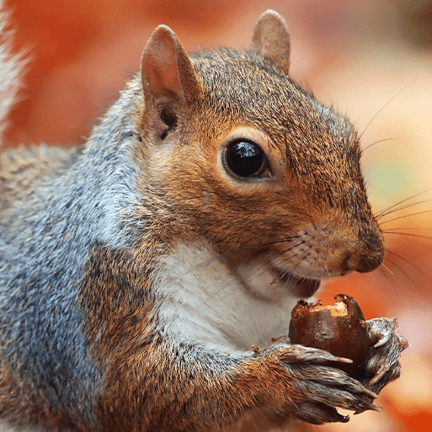  FOCUS: Understanding the World  MEMORABLE EXPERIENCE: Woodland visit | Project:  ONCE UPON A TIME  FOCUS: LITERACY  MEMORABLE EXPERIENCE: Teddy Bears Picnic | Project:  MOON ZOOM  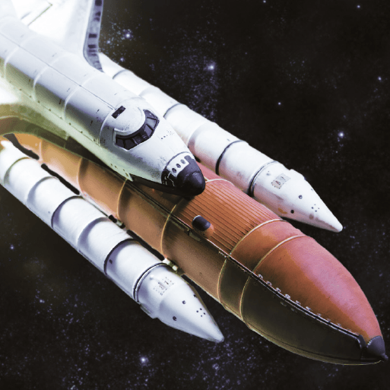  FOCUS: DT  MEMORABLE EXPERIENCE: Alien Crash | Project:  BRIGHT LIGHTS BIG CITY  KRP  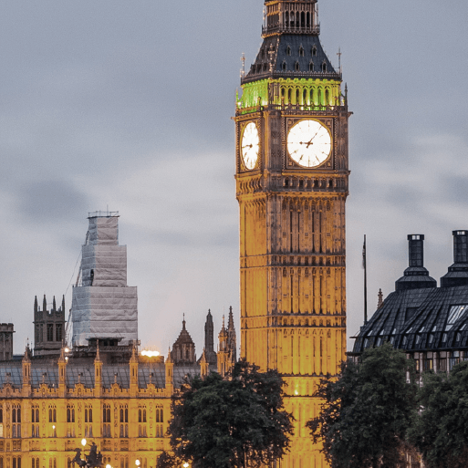  FOCUS: Geography  MEMORABLE EXPERIENCE:  Afternoon tea with the Queen | Project:  CLAWS PAWS AND WHISKERS  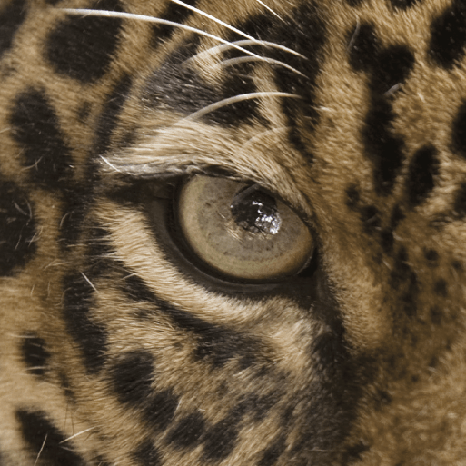  FOCUS: Art and DT  MEMORABLE EXPERIENCE:  Visit from an animal owner | Project:  SPLENDID SKIES  FOCUS: Science  MEMORABLE EXPERIENCE:  Nature walk
Year 2 Project | TERM 1 | TERM 2 | TERM 3 | TERM 4 | TERM 5 | TERM 6
 | Project:  LAND AHOY  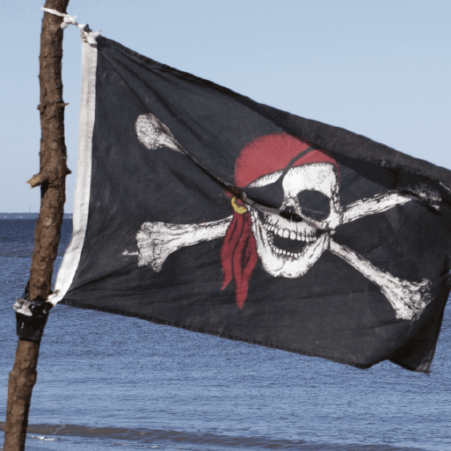  FOCUS: Geography  MEMORABLE EXPERIENCE: Pirate Visit |  | Project:  SUPERHEROES  MOVERS AND SHAKERS  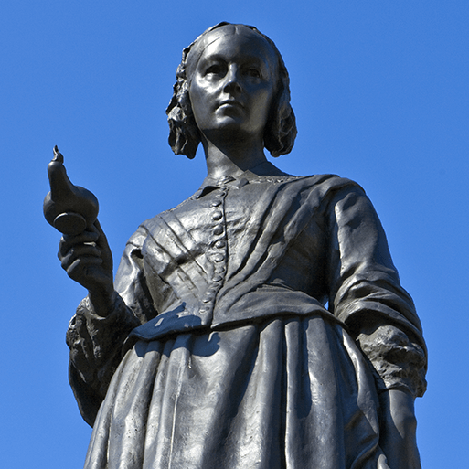  FOCUS: History  MEMORABLE EXPERIENCE: Superhero wow day | Project:  WRIGGLE AND CRAWL  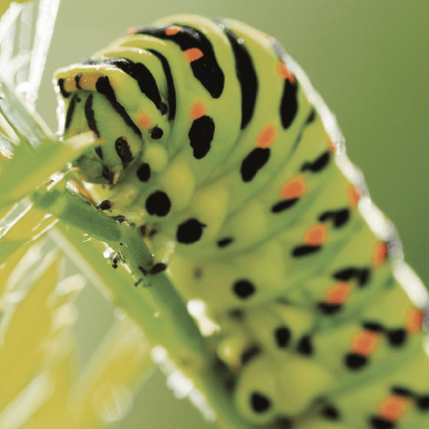  FOCUS: Science  MEMORABLE EXPERIENCE: Mini beast hunt | Project:  THE SCENTED GARDEN  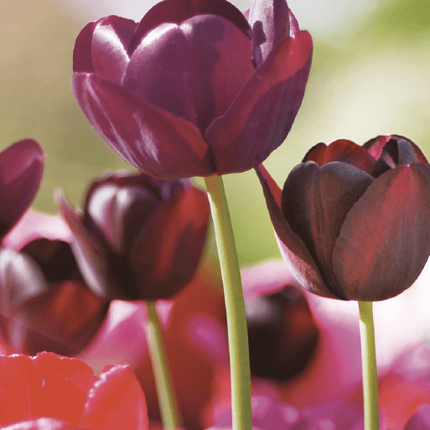  FOCUS: Science  MEMORABLE EXPERIENCE: Garden centre visit | Project:  COASTLINE  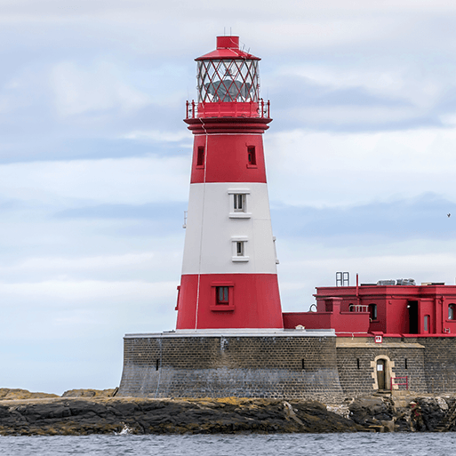  FOCUS: Geography  MEMORABLE EXPERIENCE:  Beach Visit

Year 3  Project | TERM 1 | TERM 2 | TERM 3 | TERM 4 | TERM 5 | TERM 6
 | Project:  ROCKS RELICS AND RUMBLES KRP  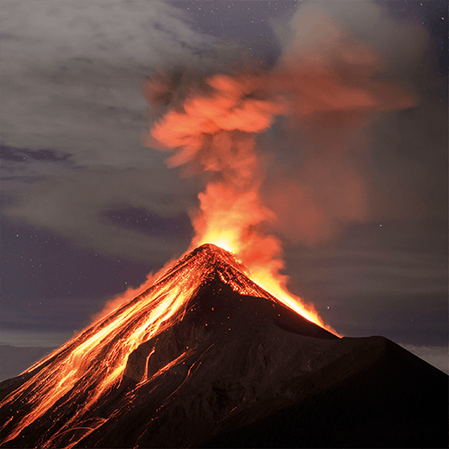  FOCUS: Geography  MEMORABLE EXPERIENCE: Rock Investigation | Project:  THROUGH THE AGES KRP  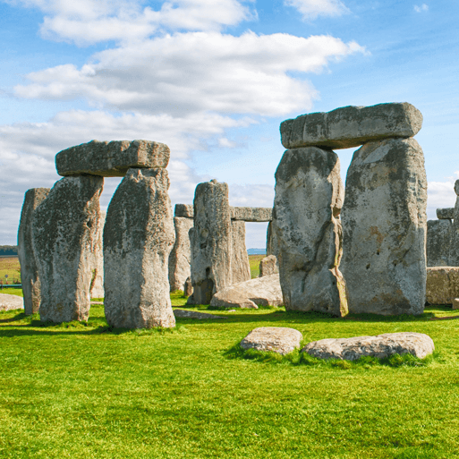  FOCUS: History  MEMORABLE EXPERIENCE:  Pre – historic visit | Project:  PREDATOR  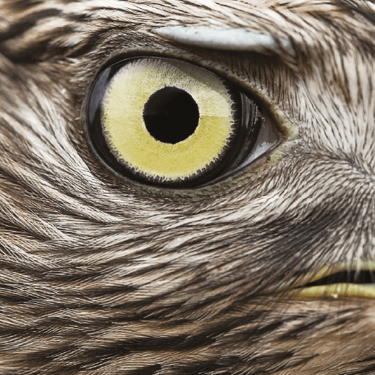  FOCUS: Science  MEMORABLE EXPERIENCE: Animal experience | Project:  EMPERORS AND EMPIRES KRP  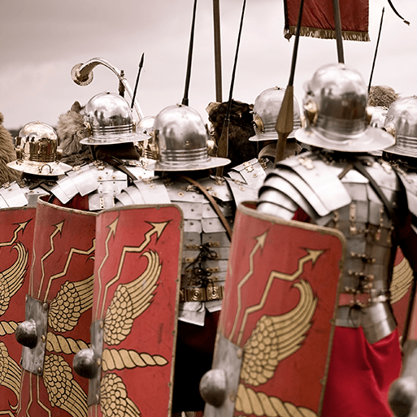  FOCUS: History  MEMORABLE EXPERIENCE: Living museum | Project:  MIGHTY METALS  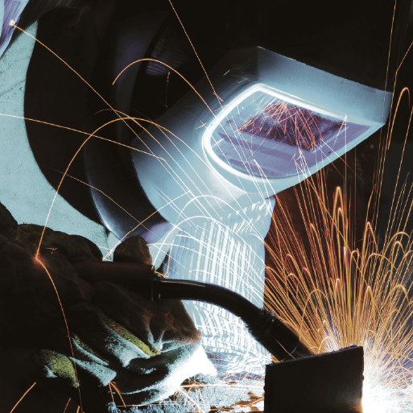  FOCUS: Science  MEMORABLE EXPERIENCE: Playground investigation | Project:  URBAN PIONEERS  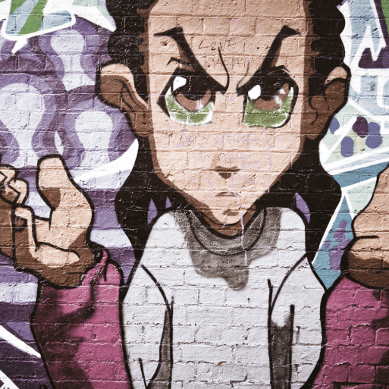  FOCUS: Art and DT  MEMORABLE EXPERIENCE: Urban walk around
Year 4  Project | TERM 1 | TERM 2 | TERM 3 | TERM 4 | TERM 5 | TERM 6
 | Project:  MISTY MOUNTAIN WINDING RIVER KRP  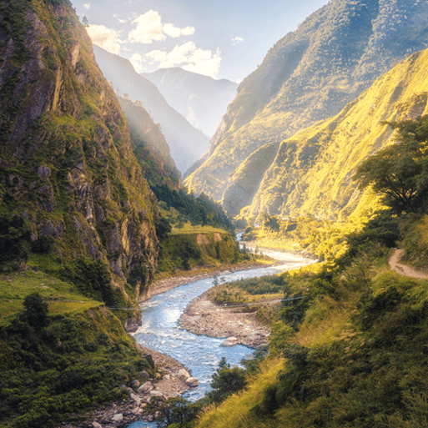  FOCUS: Geography  MEMORABLE EXPERIENCE: River visit | Project:  BURPS BOTTOMS AND BILE  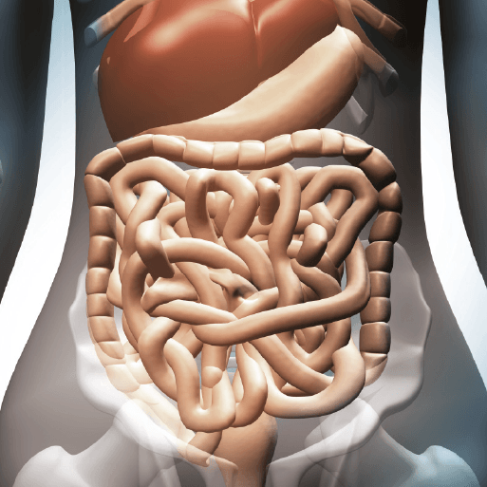  FOCUS: Science  MEMORABLE EXPERIENCE: Visit a Local Visit | Project:  TRADERS AND RAIDERS  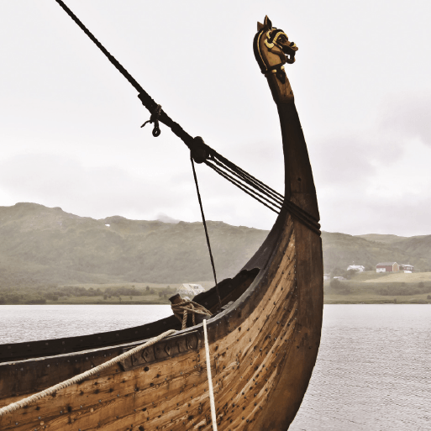  FOCUS: History  MEMORABLE EXPERIENCE: Making sailing boats | Project:  PLAYLIST  FOCUS: Music  MEMORABLE EXPERIENCE: Live Musical Performance | Project:  BLUE ABYSS  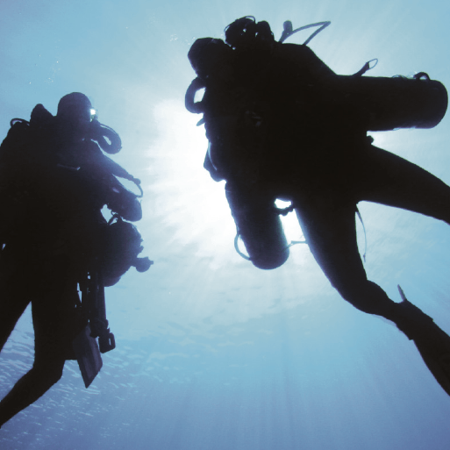  FOCUS: Science  MEMORABLE EXPERIENCE: Aquarium Visit | Project:  POTIONS  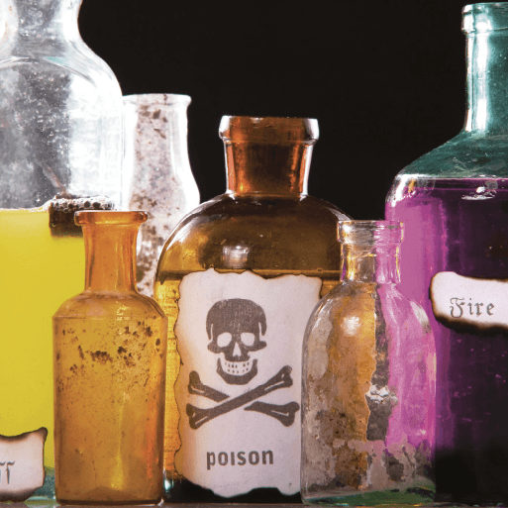  FOCUS: Science  MEMORABLE EXPERIENCE: Discovery Trail

Year 5 Project | TERM 1 | TERM 2 | TERM 3 | TERM 4 | TERM 5 | TERM 6
 | Project:  SOW GROW and FARM KRP  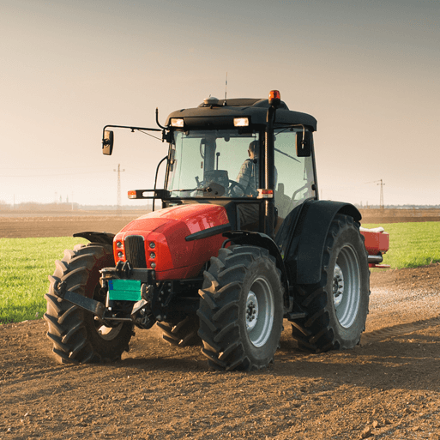  FOCUS: Geography  MEMORABLE EXPERIENCE: Allotment visit | Project:  OFF WITH HER HEAD  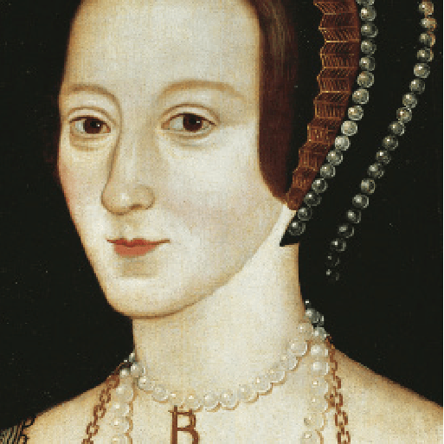  FOCUS: History  MEMORABLE EXPERIENCE: Hot Seating | Project:  STARGAZERS  FOCUS: Science  MEMORABLE  EXPERIENCE: Planetarium visit | Project:  SCREAM MACHINE  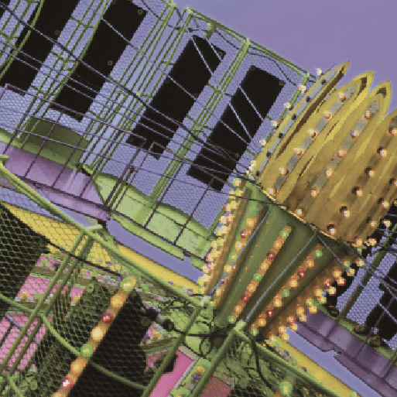  FOCUS: Science  MEMORABLE EXPERIENCE: Fairground visit | Project:  ALCHAMY ISLAND  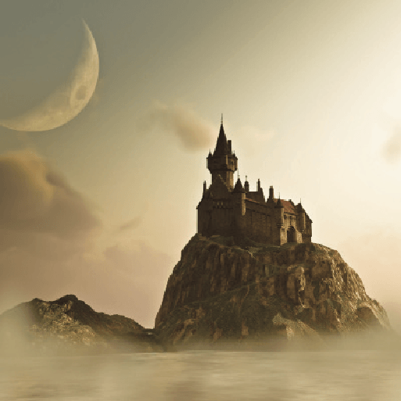  FOCUS: Music  MEMORABLE EXPERIENCE: Riddle to solve | Project:  GROUNDBREAKING GREEKS  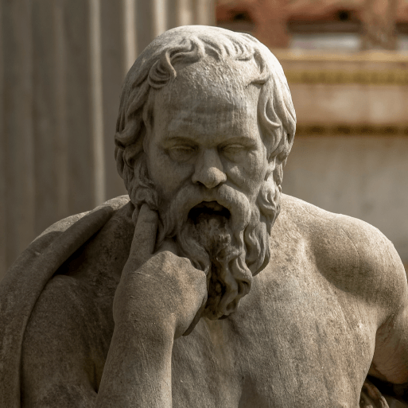  FOCUS: History  MEMORABLE EXPERIENCE: Time teams
Year 6 Project | TERM 1 | TERM 2 | TERM 3 | TERM 4 | TERM 5 | TERM 6
 | Project:  FROZEN KINGDOM KRP  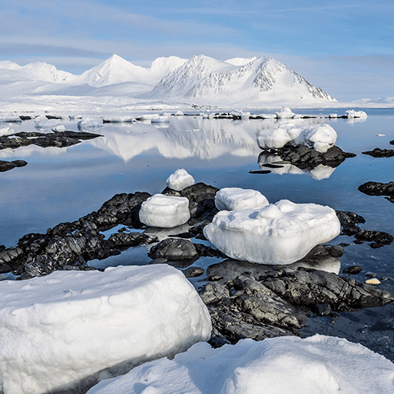  FOCUS: Geography  MEMORABLE EXPERIENCE: Polar Expedition | Project:  ID  FOCUS: Science  MEMORABLE EXPERIENCE: Meet John Doe | Project:  A CHILDS WAR  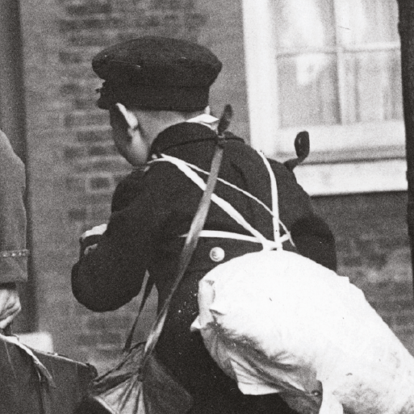  FOCUS: History  MEMORABLE EXPERIENCE: Evacuation | Project:  BLOOD HEART  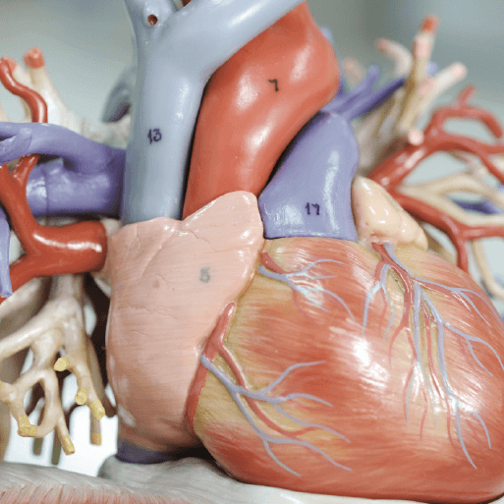  FOCUS: Science  MEMORABLE EXPERIENCE: Heart Dissection | Project:  MAAFA KRP  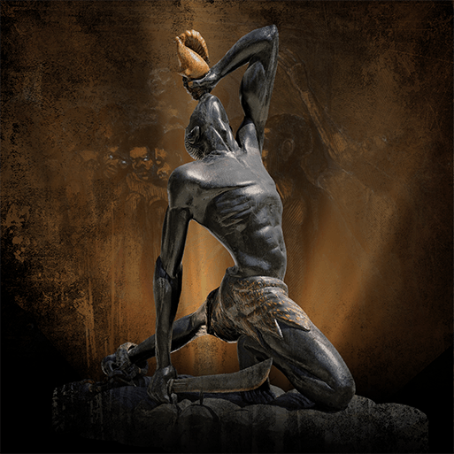  FOCUS: History  MEMORABLE EXPERIENCE: Exploring Africa today | Project:  TRANSITION / PRODUCTION

